 |  | 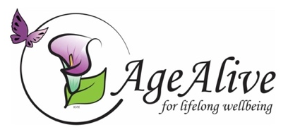
AgeAlive’s Town & Gown August–December 2021

5pm Tuesday, Aug 31  Gabriella Karin  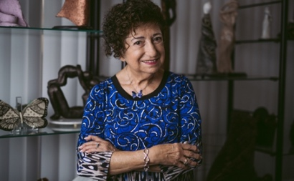 | Gabriella Karin is a survivor of the Holocaust. She is dedicated to educating young people in schools, at the Holocaust Museum Los Angeles, and the Museum of Tolerance. She has been invited to schools, synagogues, youth camps, and many other events to help students to understand the history of the Holocaust so that it is not repeated. Gabriella is also an accomplished artist whose work is inspired by the Holocaust. Last year, Gabriella published her memoir, Trauma, Memory, and the Art of Survival: A Holocaust Memoir, which tells her incredible story of survival as a Jewish girl in Bratislava whose family was forced into hiding during the Nazi occupation of Czechoslovakia.
5pm Tuesday, September 7  Sheril Kirshenbaum  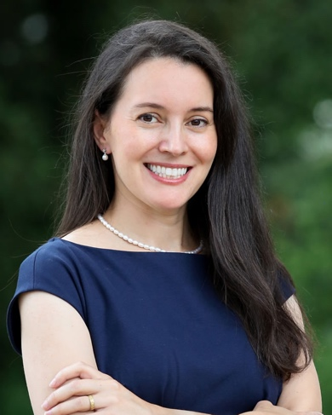 | Sheril Kirshenbaum is a scientist and author working to enhance public understanding of science. She currently hosts Serving Up Science at PBS Digital Studios and is executive director of Science Debate, a nonprofit nonpartisan organization working to get every candidate on record on science policy. At Michigan State University, Sheril hosts ‘Our Table’, a series of round table discussions bringing together farmers and food experts, health professionals and community members to foster dialogue about where our food comes from and how it impacts our health and planet. Sheril co-wrote Unscientific America: How Scientific Illiteracy Threatens Our Future with Chris Mooney (chosen by the Library Journal as one of the Best Sci-Tech Books of 2009 and named by President Obama's science advisor John Holdren as a top recommended read). She is also the author of The Science of Kissing, which explores the science behind one of humanity's fondest pastimes.
5pm Tuesday, September 14  Dr. Kevin Elliott  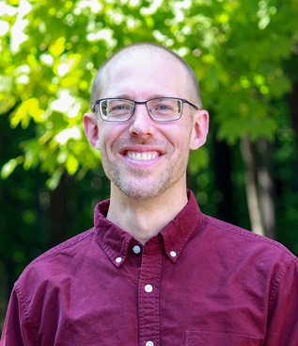 | Dr. Kevin Elliott (Lyman Briggs College & Department of Philosophy) studies the ethical and social values that play into scientific research, especially in policy-relevant areas of environmental research. He has explored the influences of financial conflicts of interest in research, ethical issues that arise in science communication, and collaborative authorship practices in science teams. Dr. Elliott works with such scientific and policy organizations as the European Food Safety Authority and the U.S. National Academy of Sciences. He is the author of Is a Little Pollution Good for You? Incorporating Societal Values in Environmental Research (2011) and A Tapestry of Values: An Introduction to Values in Science (2017).
5pm Tuesday, September 21  Dr. Amanda Flaim  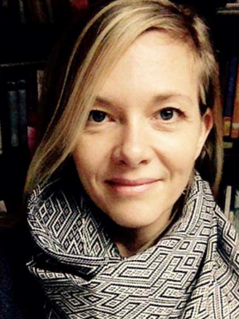 | Dr. Amanda Flaim (James Madison College, Department of Sociology, and Center for Gender in Global Context) is a political sociologist who studies human rights policy and development programs in mainland Southeast Asia. She researches indigenous and ethnic minority communities in upland Thailand, examining how their vulnerability affects health outcomes, educational attainment, population movements, and land-use/land claims. Dr. Flaim is currently collaborating with fellow MSU/JMC faculty and students, as well as artists, activists, UNESCO, and leading faculty partners in Southeast Asia, to explore the possibilities for less damaging environmental policies along the imperiled Mekong River and its tributaries. This session is held in association with the Great Decisions program of the Foreign Policy Association.
5pm Tuesday, September 28  Dr. stef shuster  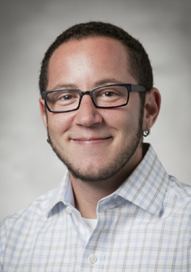 | Dr. stef m. shuster (Lyman Briggs College and Department of Sociology) studies the social aspects of medicine, science, and gender. Dr. shuster’s recent book, Trans Medicine: The Emergence and Practice of Treating Gender (New York University Press, 2021), examines how scientists and doctors come to have the authority to define gender. Trans Medicine traces the development of this medical field from the 1950s to the modern day to show how providers, facing vast uncertainty, make medical decisions in their work with transgender patients and create scientific and medical evidence to ‘treat’ a gender identity.  You can also read about Dr. shuster’s research in this article in The Conversation.
5pm Tuesday, October 5  Dr. Benjamin Smith  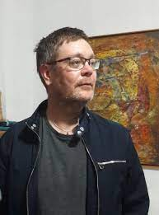 | Dr. Benjamin Smith (Department of History, University of Warwick, UK) is a historian of modern Mexican history at Warwick University in the UK who also taught at MSU between 2004 and 2013. Dr. Smith has done most of his research in the archives, villages, churches, and markets of the predominantly indigenous state of Oaxaca.  The author of several books on politics and religion in Mexican history, Dr. Smith has just published The Dope: The Real History of the Mexican Drug Trade, a myth-busting, 100-year history of the Mexican drug trade. Dr. Smith draws on unprecedented archival research, leaked DEA, Mexican law enforcement and cartel documents, and dozens of harrowing interviews, to tell the real story of how and why this one-peaceful industry turned violent. The Financial Times describes The Dope as a ‘Magisterial and immensely readable... True crime at its historical best, replete with all the larger-than-life characters and thrills and spills of a Netflixnarco drama.’
5pm Tuesday, October 12  Dr. Mónica Ramírez-Montagut  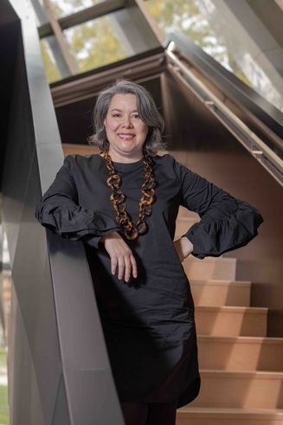 | Dr. Mónica Ramírez-Montagut (Director, MSU Broad Museum) is a devotee of museums. Born in Mexico City, Dr. Ramírez-Montagut joined the MSU Broad team in 2020 after having served as director at the Newcomb Art Museum of Tulane University in New Orleans, Louisiana. Throughout her extensive career, her approach to art is known for being both publicly engaged and socially conscious. Dr. Ramírez-Montagut received her Ph.D. in theory and history of architecture from Universitat Politécnica de Catalunya in Barcelona, Spain.  A trained architect, Dr. Ramírez-Montaguco-curated the 2006 Zaha Hadid retrospective at the Guggenhiem Museum in NYC and then made the professional shift to work with contemporary artists. In 2020, Dr. Ramírez-Montagut joined the Board of Trustees of the U.S. International Council for Museums (ICOM), the Association of Art Museum Directors (AMMD), and was one of the panelists of the U.S. Department of State’s Bureau of Educational and Cultural Affairs that selected artist Simone Leigh to represent the US in the 2022 Venice Biennale.
5pm Tuesday, October 19  Dr. Jennifer Cobbina | Dr. Jennifer Cobbina is in the School of Criminal Justice at MSU. Her research focuses on corrections, prisoner reentry, and the understanding of recidivism and desistance among recently-released female offenders. Her second research area is centered on examining how race, gender, and neighborhood context impact victimization risks among minority youth.  Dr. Cobbina recently published Hands Up, Don't Shoot: Why the Protests in Ferguson and Baltimore Matter, and How They Changed America (New York University Press, 2019), an on-the-ground assessment of the powerful, protestor-driven movement around race, justice, and policing in America. Last year, Dr. Cobbina gave expert testimony to the MI Senate Judiciary Committee regarding ‘clean slate’ legislation. Clean slate is a package of bills which would create automatic expungements for former offenders who have lived a crime-free life for 7 years
5pm Tuesday, October 26  Dr. Matt Grossmann  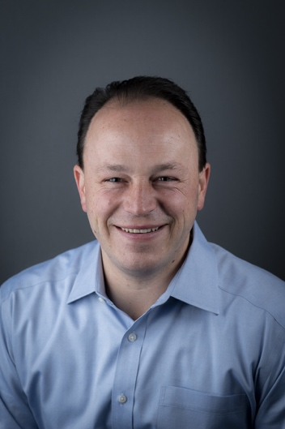 | Dr. Matt Grossmann (Department of Political Science & Director of the Institute for Public Policy and Social Research) is a political scientist whose work focuses on party politics, special interests in politics, and methods in the social sciences. His books include The Not-So-Special Interests: Interest Groups, Public Representation and American Governance (Stanford University Press, 2012), Artists of the Possible: Governing Networks and American Policy Change Since 1945 (Oxford University Press, 2014), Red State Blues: How the Conservative Revolution Stalled in the States (Cambridge University Press, 2019), and How Social Science Got Better: Overcoming Bias with More Evidence, Diversity, and Self-Reflection (Oxford University Press, 2021).  Dr. Grossmann is a Senior Fellow at the Niskanen Center in Washington, DC, host of The Science of Politics Podcast and a regular contributor to FiveThirtyEight’s online political analysis. He has also published op-eds in The New York Times and The Washington Post.
5pm Tuesday, November 2  Dr. David Lowry  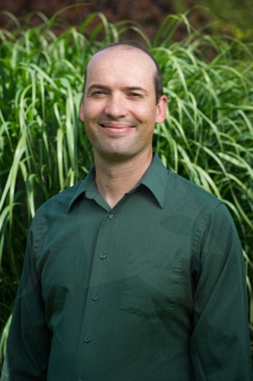 | Dr. David Lowry (Department of Plant Biology) manages a lab at MSU which studies how plants adapt to new ecological demands, how new species arise, and how this knowledge can help us in developing improved crop species. Among his many other publications, Dr. Lowry is a co-author on a recent Nature article which examines how climate change will threaten food and fuel security and how knowledge of the genetics of certain crops can help alleviate the dangers of food and fuel shortages. In addition, Dr. Lowry is in charge of one of the world’s longest-running experiments. At 142 years old, the Beal seed experiment involves digging up seeds planted in locations around MSU to find out how long they can remain dormant and still germinate. Earlier this year, the New York Times told the story of this remarkable experiment which is expected to continue for another eighty years!
5pm Tuesday, November 9  Dr. Morteza Mahmoudi  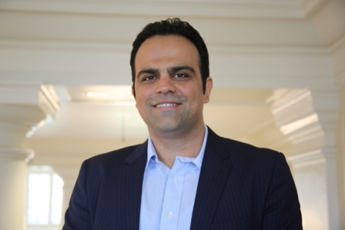 | Dr. Morteza Mahmoudi (Department of Radiology) is the Principal Investigator in the Precision Health Program at MSU. Prior coming to MSU, he was an Assistant Professor of Anesthesiology at Brigham and Women’s Hospital, Harvard Medical School. His research interest is in nanomedicine and regenerative medicine for the development of new nano-based platforms for prevention/treatment of life-threatening conditions such as cardiomyopathy, cancer, and neurodegenerative diseases. Aside from nanomedicine and regenerative medicine, Dr. Mahmoudi is also very active in social sciences and specifically in drawing the attention of the scientific community in the rising issue of academic bullying. He is among 2018 highly cited researchers in 2018 as reported by Clarivate Analytics.
5pm Tuesday, November 16  Nicole Jedding, Kate Frieden & Macken Keefe  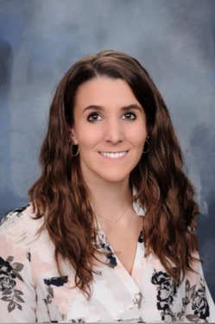 | Nicole Jedding, a former Social Science Scholar, is currently studying for an MPhil in Policy Evaluation at the University of Oxford and both Kate Frieden and Macken Keefe are current Social Science Scholars. They will be talking about a remarkable and award-winning research project which will shortly be published in a high-profile academic journal. The project, initiated by Nicole in 2018, was designed to test the common assertions (a) that cocaine users were far more often demonized than opioid users and (b) that this has to do with implicit racism. Testing these hypotheses involved coding hundreds of hours of NBC Nightly News segments related to cocaine use in the 1980s and opioid misuse in the 2010s. The results are powerful and important.
5pm Tuesday, November 23  Dr. Stan Kaplowitz  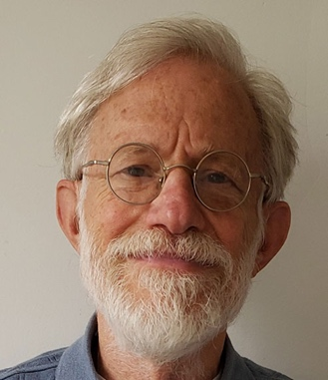 | Dr. Stan Kaplowitz, Professor Emeritus of MSU’s Department of Sociology specializes in social psychology, especially of attitudes and communication. He has taught Political Sociology for many years and has thoroughly studied the group basis of American voting behavior. In addition, Dr. Kaplowitz has published articles on persuasion, attitude change over time, racial attitudes and beliefs, and physician patient communication, and attitudes towards climate change policies, donating tissue to biobanks and a major MSU riot.  Dr. Kaplowitz also applies quantitative methods to predicting risk of lead poisoning from environmental and socio-demographic data. A major part of Dr. Kaplowitz’s current research involves finding ways of increasing energy conserving behavior and increasing public support for energy conservation policy. To this end, he has studied attitudes towards the gasoline tax and carpooling.
5pm Tuesday, November 30  Dr. Susan Sleeper-Smith  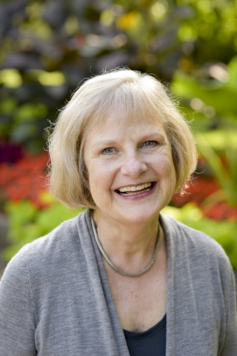 | Dr. Susan Sleeper-Smith, Professor Emerita of History at Michigan State University, examines Native American-Euro-American encounters during the colonial and early national histories of North America. She focuses on sites of encounter, particularly borderlands, where diverse people interacted and where identity, initially malleable, changed over time. Dr. Sleeper-Smith is the author of Indian Women and French Men: Rethinking Culture Encounter in the Great Lakes, Rethinking the Fur Trade, and Contesting Knowledge: Museums and Indigenous Perspectives.  Dr. Sleeper-Smith’s most recent book is entitled Indigenous Prosperity and American Conquest: Indian Women of the Ohio River Valley, 1690-1792 (University of North Carolina Press, 2018) and explains how the labor of women transformed the economy along the Ohio River. In addition, committed to improving the teaching of Native American history, Dr. Sleeper-Smith co-edited Why You Can’t Teach United States History without American Indians (UNC Press, 2015).
5pm Tuesday, December 7  Professor Melanie Helton  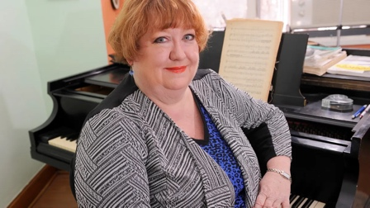 | Melanie Helton is professor of voice (soprano) and director of the MSU Opera Theatre at the Michigan State University College of Music. She has been hailed by The New York Times for her ‘dark soprano that warms the ear.’ Professor Helton’s successes include the title roles in Lucrezia Borgia at the Caramoor International Music Festival and Aida with Opera Carolina, as well as Donna Anna in Don Giovanni with Caramoor, Opera Carolina, Donna Elvira in Don Giovanni for New York City Opera, and the title role in Norma for Teatro de Colon, Bogotà. In addition, she has sung leading roles with the Santa Fe Opera, Houston Grand Opera, Dallas Opera, Washington Opera, and San Francisco Opera Center. A favorite of American composers, Professor Helton worked directly on the creation of the role of Dede with Leonard Bernstein on his only full-length opera, A Quiet Place, and the role of Ariel in Lee Hoiby’s The Tempest. As a stage director, she has helmed the American premiere of Francisco Conti’s Don Quixote in Sierra Morena, as well as the world premiere of Donizetti's long-lost French opera, Elisabeth, both at the Caramoor Festival. Her production of The Pirates of Penzance for MSU Opera Theatre recently won first prize in Division III of the National Opera Association’s opera production competition.
Noon Tuesday, December 14  Dr Erica Frantz  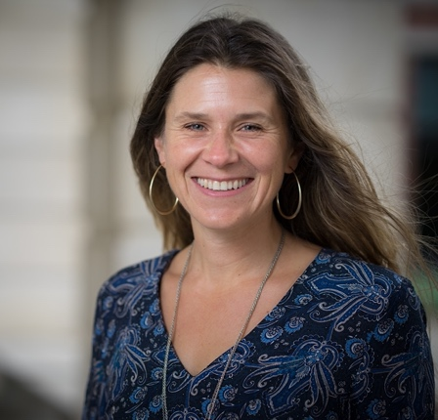 | Dr. Erica Frantz (Department of Political Science) specializes in the study and teaching of authoritarian politics, democratization, conflict, and development. She is particularly interested in the security and policy implications of autocratic rule. Her numerous books include: Democracies and Authoritarian Regimes (Oxford University Press, 2019, with Andrea Kendall-Taylor and Natasha Lindstaedt);m Authoritarianism: What Everyone Needs to Know. Oxford University Press, 2018; How Dictatorships Work: Power, Personalization, and Collapse (Cambridge University Press, 2018, with Barbara Geddes and Joseph Wright); and Development and the State in the 21st Century: Tackling the Challenges Facing the Developing World (Palgrave Publishing, 2015, with Natasha Ezrow and Andrea Kendall-Taylor). Also an accomplished teacher, in 2020 Dr. Frantz won MSU’s College of Social Science Outstanding Teacher Award.
Please click on this link to receive email notifications about Town and Gown.

