Town & Gown Spring 2022 Line-Up

Public Health and Child Development in The Sub-Sahara: One Professor’s Journey and Mission
Tuesday March 8th, 5pm

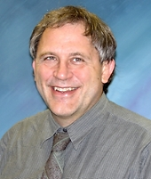
Professor Michael Boivin (Departments of Psychiatry, Neurology and Ophthalmology), has devoted his career to improving the wellbeing of children in Benin, Malawi and Uganda affected by such diseases as HIV, cerebral malaria, and maternal anemia. In recent years, Dr. Boivin has carried out important work in showing how simple interventions can improve the social skills, mental health, language, and cognitive ability of children whose parents have HIV-AIDS or have died from the disease. He is also exploring the neurocognitive effects of cerebral malaria.

The Current Situation in Ukraine
Tuesday March 22nd, 5pm

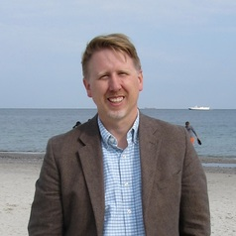
Professor Matthew Pauly (Department of History) is a historian of Ukraine and Eastern Europe, nationalism, education, childhood, and human rights. In 2014, Professor Pauly published Breaking the Tongue: Language, Education, and Power in Soviet Ukraine, which discusses Ukrainization under Soviet rule and its ultimate effects. He is a core faculty member of the Center for European, Russian, and Eurasian Studies, as well as Peace and Justice Studies, at MSU. Professor Pauly has lived and worked extensively in Ukraine and, since the war began, has given several talks on the on-going situation in the country.

Why We Make the Investment Decisions That We Make
Tuesday March 29th, 5pm

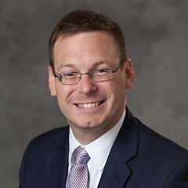
Professor Stephen Schiestel, CFA holds the Addy Professorship of Practice in Finance at the MSU Broad School of Business. A passionate educator and financial advisor, he is dedicated to improving personal financial education and financial decision making. A full-time teacher of finance at MSU, Stephen is also an owner of Grand Capital Advisors.

Exploring the Hidden Histories of Asian Americans
Tuesday April 5th, 5pm

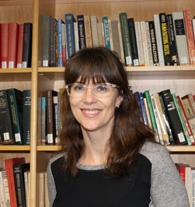
Professor Anna Pegler-Gordon (James Madison College) is a historian of Asian American history, immigration policy, citizenship, comparative race and ethnic relations, and U.S. racial and immigration history. She has just published, and will be talking about, her new book: Closing the Golden Door: Asian Migration and the Hidden History of Exclusion at Ellis Island, a fascinating study of Asian immigrants, sailors, smugglers, detainees, and deportees at Ellis Island.

Preparing a Performance of Verdi's Requiem
Tuesday April 12th, 5 pm
Professor David Rayl, DMA, is a professor of music, director of choral programs and senior associate dean for graduate and research at the MSU College of Music. A passionate and active instructor, he has personally advised over 100 doctoral and master’s students in choral conducting. As a conductor, Dr. Rayl has led performances both across the US and around the world, including the Church of the Madeleine in Paris, the National Center for the Performing Arts in Beijing, and the Maggio Musicale in Florence.

How People Around Us Influence Our Decisions
Tuesday April 19th, 5pm

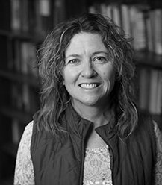
Professor Maria Lapinski (Department of Communication) is Director of the Michigan State University (MSU) Health and Risk Communication Center. A global expert on how to improve health and wellbeing by means of designing persuasive messaging. She has carried out projects in Asia, the Pacific Rim, Central America, and Africa and North America on topics as varied as reducing the transmission of HIV, improving perceptions of risks of shark attacks among divers, promoting conservation practices in Tibet, and lessening the risks of people contracting wild animal diseases.

Professor Leo Zulu
TBD - Postponed

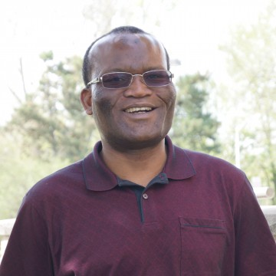
Professor Leo Zulu (Geography, Environment, and Spatial Sciences) studies the relationship between people and environments in Africa. He has worked on deforestation and food security, community-based natural resources management, and the vulnerability and adaptation of rural communities in southern Africa to climate change

Professor Satish Udpa
TBD - Postponed

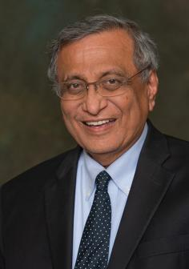
Professor Satish Udpa is University Distinguished Professor of Electrical and Computer Engineering, former Acting President of Michigan State University, former Dean of the College of Engineering, and a former Chair of the Department of Electrical and Computer Engineering. Professor Udpa is currently serving as the Interim Director of Mobility and will be talking about the future of transport as well as about MSU’s new autonomous bus.

To register, visit: https://msu.co1.qualtrics.com/jfe/form/SV_0DFc95rd1eFHHkV

Reverend Doctor Shawnthea Monroe
Tuesday May 10th, 5PM

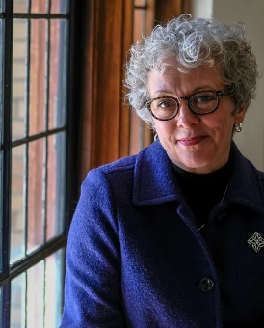
Rev. Dr. Swanthea Monroe is the senior pastor at the People’s Church here in East Lansing and is the first woman to ever fulfill the role. A South-Dakota native, she has been working in ordained ministry for over 20 years. Dr. Monroe has also taught courses on theology, preaching, and contemporary culture as part of the American Academy of Religion.

Electric Motors and Additive Manufacturing
Tuesday May 17th, 5PM
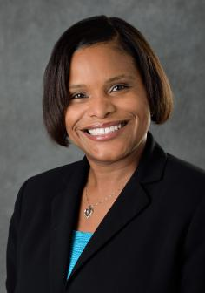
Professor Shanelle Foster is a professor of Electrical and Computer Engineering at MSU. Focusing on the development of a cleaner electric motor, Dr. Foster recently received an NSF CAREER award—one of the most prestigious in the nation—to fund her latest innovative project: designing a more efficient electric motor system with the help of 3-D modeling.

